Customer instructions to setup Debug logs

Here are the steps you need to follow:

- Right click on Autodesk Desktop App system tray menu > Exit
It might be hidden so expand hidden icons if necessary.

- Open Task Manager > Service tab, right click AdAppMgrSvc and select Stop Service

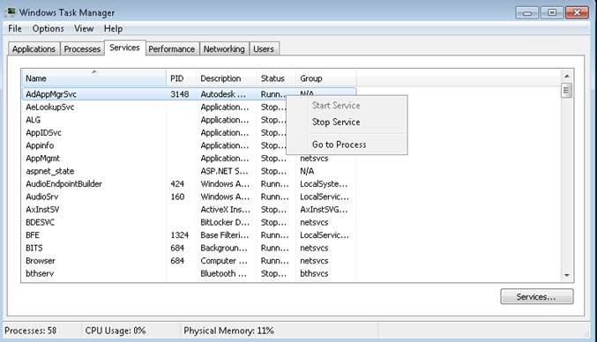

- Edit Autodesk Application Manager Service.ini file at %programdata%\Autodesk\
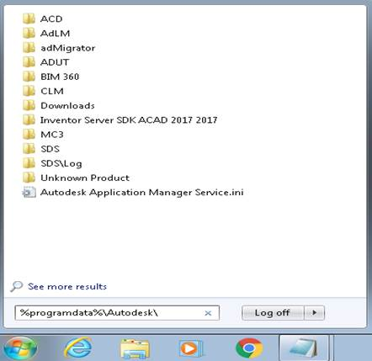

Under [General] section, add
LoggingLevel=0
debugIPC=1

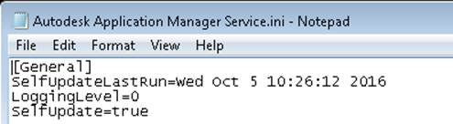

- Save the file. If you do not have permission to save it, then first copy it to the desktop, edit & paste it back to the same location.

- Open Task Manager > Service tab, right click AdAppMgrSvc and select Start Service

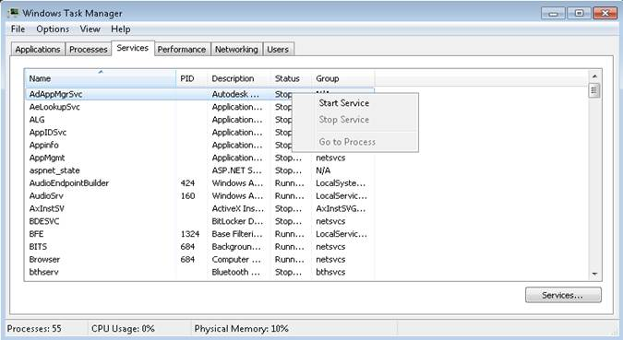

- From Windows Search, search for “Edit the system environment variables”

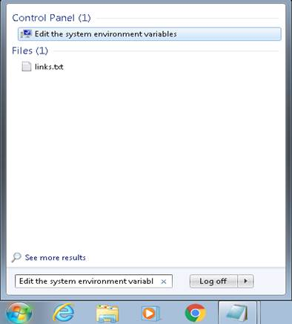

- Click Environment Variables… button. In the section User variables for admin, click New… button to add below 2 new user variables
WM_ENABLE_LOG = true
WM_LOG_LEVEL = debug

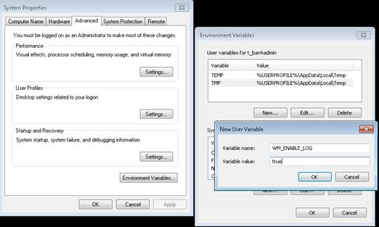
- Re-launch Autodesk Desktop App
- Copy the log files under below location, zip or rar them and send them to me
%ProgramData%\Autodesk\SDS\Log
%localappdata%\Autodesk\Autodesk Desktop App

